

**COMSATS University Islamabad,**



**COMSATS Road, off GT Road, Sahiwal, Pakistan**

**Project Proposal**

**for**

**<BLOCKCHAIN BASED E-VOTING SYSTEM>**

Version 1.0

***By***

**Sheharyar Jamil** **CIIT/FA-BCS-017/SWL**

**Shahzaib Naeem** **CIIT/FA-BCS-042/SWL**

**Zubair Amin** **CIIT/FA-BCS-051/SWL**

***Supervisor***

***Mr. Nasir Mehdi***

***Co-Supervisor***

***MR. AMIR ALI***

***Bachelor of Science in Computer Science (2018-2022)***

**Project Title**

Blockchain-Based E-Voting System

**Project Advisor**

Mr. Nasir Mehdi

**Project Co-Supervisor**

Mr. Amir Ali

**Of the students:**

|  |  |  |  |  |  |  |  |  |
| --- | --- | --- | --- | --- | --- | --- | --- | --- |
| **S. No** | | **Registration#** | **Name in Full** | **CGPA** | | **Email** | | **Signatures** |
| 1 | | FA18-BCS-017 | Sheharyar Jamil | 3.02 | | [sheharyarjamil29@gmail.com](mailto:sheharyarjamil29@gmail.com) | |  |
| 2 | | FA18-BCS-042 | Shahzaib Naeem | 2.64 | | [shahzaib.naeem2122@gmail.com](mailto:shahzaib.naeem2122@gmail.com) | |  |
| 3 | FA18-BCS-051 | | Zubair Amin | 2.62 | [zubairamin695@gmail.com](mailto:zubairamin695@gmail.com) | |  | |

**Advisor’s Consent**

I Prof. /Dr. /Mr. /Ms. ________________________________________________ am willing to guide these students in all phases of above-mentioned project / thesis as advisor. I have carefully seen the Title and description of the project / thesis and believe that it is of an appropriate difficulty level for the number of students named above.

**Co- Advisor’s Consent**

I Prof. /Dr. /Mr. /Ms. ________________________________________________ am willing to guide these students in all phases of above-mentioned project / thesis as advisor. I have carefully seen the Title and description of the project / thesis and believe that it is of an appropriate difficulty level for the number of students named above.

|  |  |
| --- | --- |
| Signatures and Date   |  | | --- | |  |   **Advisor** |
| Signatures and Date   |  | | --- | |  |   **Co-Advisor** |

**SCOPE DOCUMENT REVSION HISTORY**

|  |  |  |
| --- | --- | --- |
| **No.** | **Comment** | **Action** |
|  |  |  |
|  |  |  |
|  |  |  |
|  |  |  |
|  |  |  |
|  |  |  |
|  |  |  |



**Supervisor Signature**

**Date:**

Contents

1. Introduction 6

2. Problem Statement 6

Manual system: 6

Electronic-Voting: 6

3. Problem Solution for Proposed System 7

4. Related System Analysis/Literature Review 7

5. Advantages/Benefits of Proposed System 8

6. Scope 9

7. Modules 9

8. System Limitations/Constraints 9

9. Software Process Methodology 10

10. Tools and Technologies 11

11. Project Stakeholders and Roles 12

12. Team Members Individual Tasks/Work Division 13

13. Data Gathering Approach 13

14. Concepts 13

15. Gantt chart 15

16. Mockups 16

17. Conclusion 19

18. References 19

**Project Category: (**Select all the major domains of the proposed project**)**

**A-**Desktop Application/Information System **B-**Web Application/Web Application based Information System

**C-** Problem Solving and Artificial Intelligence **D-**Simulation and Modeling **E-** Smartphone Application

**F-**Smartphone Game **G-** Networks **H-** Image Processing

**I-**Other (specify category) ______________________

**Abstract**

The current system is being operated manually. Votes are polled manually through ballot papers. All the records of voters, candidates, polling stations, regions detail, and parties’ information are stored manually in the election commission of Pakistan. Results are calculated manually and there is a lot of chances of data tampering. All records are stored in registers and files. There is a big problem for the election commission to manage the records at the same time. Our proposed cost-effective online Voting system will replace the manual record-keeping system of voters, candidates; duty staff by polling the votes by a computerized system, which will reduce the chances of error occurrence, while counting, minimize time being consumed during counting, increase the security of votes being polled.

# 1. Introduction

Blockchain is a vast technology in today's era and the system developed on the blockchain technology has a great impact to change the world industries working way. One efficient example is cryptocurrency in the form of Bitcoin BTC that takes over paper currency and now it is safe to use. Blockchain collects information together in blocks and each block has different transactions. To utilize the blockchain to develop a system for the electronic voting system that provides the facilities decentralized, secure, transparent, not changeable data and traceability. That is to empower and stable the Voting system. In an electronic voting system, a voter can cast the vote, that works on the blockchain (Ethereum) and smart contracts using Dapp. The presiding officer is the person who has access to the system to manage the record, view casting, verify the voting, and initiate the transfer and document validation and authenticity. It will reduce the time cost, payment cost, provide transparency, and keep the records secure. Once the voting is done all the data record in the blockchain and the hash is generated automatically, and it cannot change that is best for security purposes.

# 2. Problem Statement

From the beginning of democracy, the main issue is to make a free and fair election. It is easy when there was no population. But in recent times the increase in the population of democratic countries. Voting becomes tough. It is a frustrating thing to cast vote and every time losing party blames the winning party that they did not hold free and fair elections. In the modern age of technology, we still depend on the following method for casting a vote

* Manual voting
* Electronic-Voting(e-vote)

Both have some limitations.

## Manual system:

Tempering (addition and subtraction of votes), counting mistakes, time delay, required a lot of manpower (including security personals)

## Electronic-Voting:

Centralized, hackable, voter verification issue, the relation of manufacturing company with any political party

# 3. Problem Solution for Proposed System

Because it’s online and decentralized it is impossible to temper data and it does not use manual counting methods, so it also overcomes the counting problem. All necessary computations are done by computer so did not take much time nor required much manpower (like in manual voting system). Unable to hack due to its blockchain technology

Our proposed cost-effective Online Voting system will replace the manual record-keeping system of voters, candidates; duty staff by polling the votes by a computerized system, which will reduce the chances of error occurrence, while counting, minimize time being consumed during counting, increase the security of votes being polled. No chances of vote rejection and easy management of records.

The system developed on the blockchain is decentralized a peer-to-peer network and does not need any third party, all nodes have equal authority, immutability that if data is saved on the blockchain cannot tamper. It provides transparency means that every node can view it publicly. To provide automation, Blockchain has smart contracts which are predefined rules in form of coding which tell that how, when, and where certain processes happened.

# 4. Related System Analysis/Literature Review

**Table 1 Related System Analysis with the proposed project solution**

|  |  |  |
| --- | --- | --- |
| **Application Name** | **Weakness** | **Proposed Project Solution** |
| Manual voting | The data can tamper | System developed on blockchain provide security, consume less time and cost, also transparency |
| Electronic Voting | Limited facilities and error-prone and centralized system | Provide an accurate system. |

# 5. Advantages/Benefits of Proposed System

* The system has decentralized and is unable to hack.
* Voter history saved permanent and reversible.
* Immutability, records cannot be tampered with by anyone.
* Secure the contracts with the cryptography technique.
* Transparency records are accessed by the public key and private key.
* Friendly to use and no prior knowledge required.
* Elections are highly based on merit

# 6. Scope

The Blockchain-based E-voting System provides the best solution for the current system problem. It will be used by government bodies, and by the people. In the Future this system provides the traceability feature that checks the previous and current voter because of blockchain. Every block connects with the previous block. It will resolve the Voting conflicts and provide security that is not hackable, and minimize the scope of vote tampering, records are transparent and checked by the public and private keys. Records data in digital ledger for transactions or contracts. The use of blockchain technology serves as the basis for a more reliable, cheaper, and more efficient land registry.

# 7. Modules

* Election Creation.
* Voter registration.
* Declaration of result

# 8. System Limitations/Constraints

* Complexity
* Human Error, Politics
* Difficult to deploy on the blockchain network.
* Transaction’s cost
* High Energy Consumption
* Lack of skilled blockchain developers

# 9. Software Process Methodology

This system will be developed module-wise.

the first step is to configure the blockchain, test networks. Then developing frontend and backend for different modules and writing smart contracts, deploying the smart contract. In Government side must view the history of the vote caster and all the rest of the co-workers. The citizen side must view properties that he can log in himself cast a vote to his favorite person, then government verifies, and all these modules integrate with the government side. Featured modules like users can see the results by using a vote counter calculator will be developed after the government-side module is completed. This software methodology is beneficial when the project is large, with early release product demand and flexible changes.

Figure 1: Incremental Model Diagram

# 10. Tools and Technologies

Table 2: Tools and Technologies for Proposed Project

|  |  |  |  |
| --- | --- | --- | --- |
| **Tools &**  **Technologies** | **Tools** | **Version** | **Rationale** |
| Visual Studio Code | 2021 | Coding and GUI |
| Ganache | 2.5.4 | Personal Blockchain for Ethereum |
| Git | 2.26.2 | For Version Controlling |
| Remix |  | Online IDE for building smart contracts |
| Rinkeby |  | Test Network |
| Ropsten |  | Test Network |
| Kovan |  | Test Network |
| MS Visio | 2013 | Gantt Chart, Use Case, Incremental Model Diagram, Flowchart, Activity Diagram. |
| MS Word for MSO 365 | 2102 | Documentation |
| MS PowerPoint for MSO 365 | 2102 | Presentation |
| **Technology** | **Version** | **Rationale** |
| Solidity | 0.4.22 | contract-oriented programming language for writing smart contracts |
| JavaScript |  | Programming language for business logic and GUI |
| Truffle |  | Development Framework provides (Ethereum Virtual Machine) |
| React | 17.0.1 | JavaScript library for building user interfaces |
| NodeJS | 14.16.0 | JavaScript run-time environment |
| IPFS | 0.7 | Distributed system for storing and accessing files |
| Hyperledger |  | Distributed ledger frameworks. |
| Web3.js | 1.3.4 | Ethereum JavaScript API |
| GitHub |  | Project Managing and Collaboration working as a team |
| Meta Mask | 9.1.1 | Accessing Ethereum enabled distributed applications |
| CSS | 3 | Styling |

# 11. Project Stakeholders and Roles

Write down the project stakeholders and their roles.

|  |  |
| --- | --- |
| **Project Sponsor** | COMSATS University Islamabad, Sahiwal campus |
| **Stakeholder** | * Sheharyar Jamil CIIT/FA-BCS-017/SWL * Shahzaib Naeem CIIT/FA-BCS-042/SWL * Zubair Amin CIIT/FA-BCS-051/SWL * Mr. Amir Ali * Final Year Project Committee: Evaluation of the project |

# 12. Team Members Individual Tasks/Work Division

Table 4Team Member Work Division for Proposed Project

|  |  |  |
| --- | --- | --- |
| Student Name | Student Registration Number | Responsibility/ Modules |
| Sheharyar Jamil | CIIT/FA-BCS-017/SWL | Documentation, Designing |
| Shahzaib Naeem | CIIT/FA-BCS-042/SWL | Documentation, Writing Smart Contracts, Coding, Blockchain Handling |
| Zubair Amin | CIIT/FA-BCS-051/SWL | Documentation, Coding, Blockchain Network Testing |

# 13. Data Gathering Approach

Techniques that are used for collecting requirements are as follows:

* Reading research papers
* Questionnaire and Survey
* Observing relevant land record websites
* Physically interaction with government land record system employees and admins
* Making Dapps
* Use of prototype

# 14. Concepts

We will learn a lot of future markets demanding skills during the development, deployment, and testing of this project. Connecting with blockchain networks locally and globally also test networks is a hard task. Writing smart contracts with solidity programming language and deployment of smart contracts on the blockchain will teach a skill that how blockchain works. And making the transaction on Dapp (Distributed App) and testing on the test network makes our concept strong. Teamwork is most important we will achieve this by using Git, GitHub for collaboration and version control. By making Frontend responsive and attractive for Dapp with different programming language also improve our design methodology of the product

# 15. Gantt chart

**Figure 1 Sample Gantt chart**

# 16. Mockups

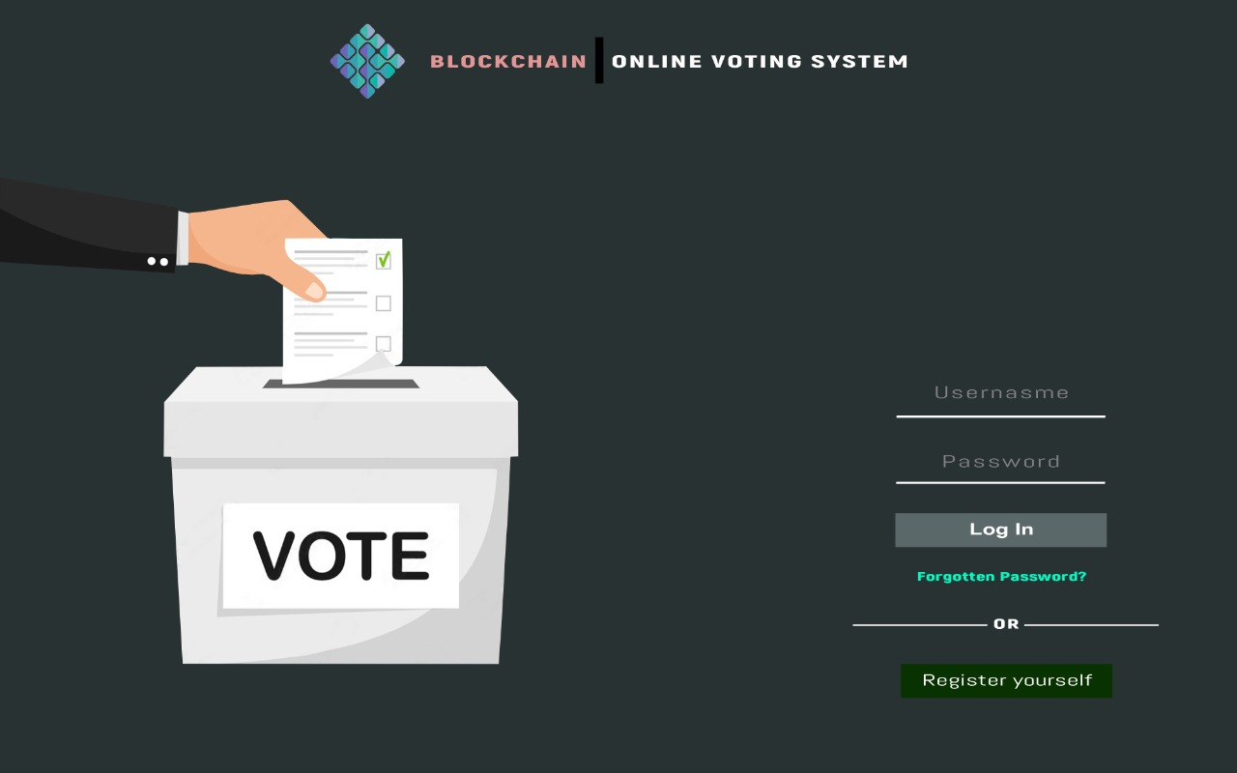

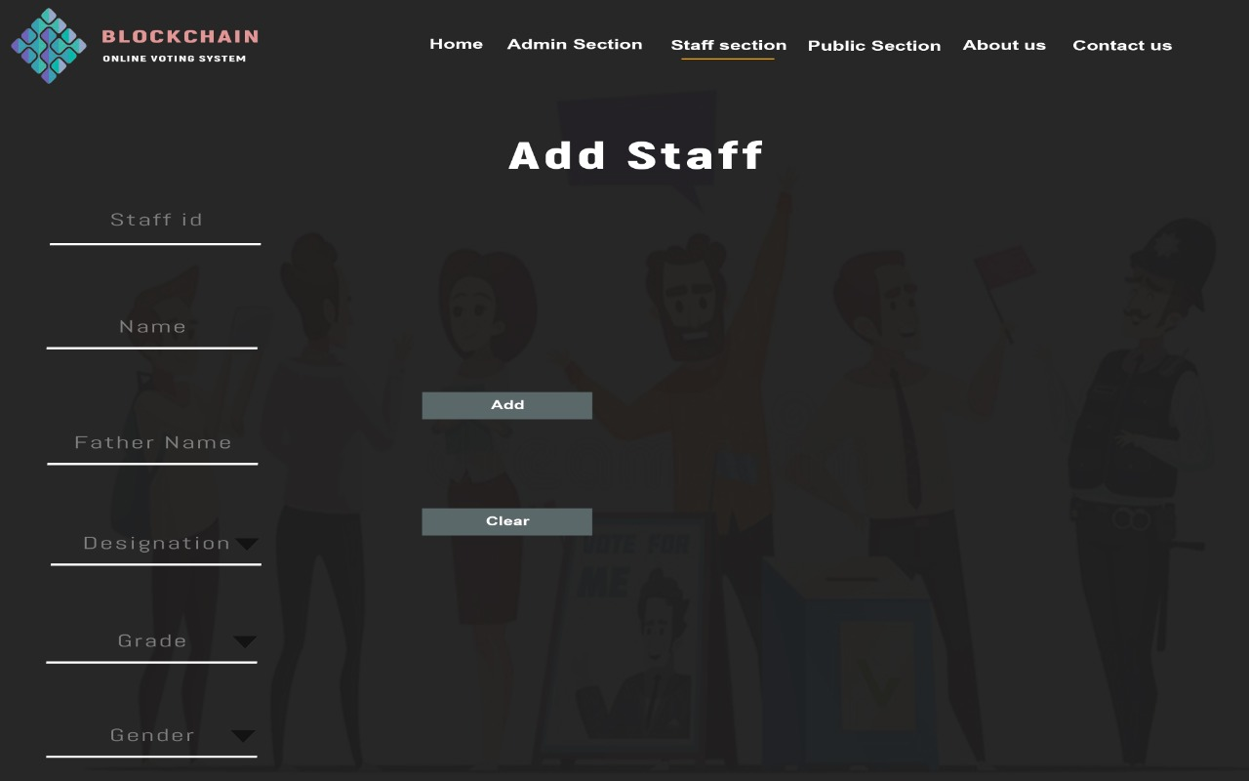

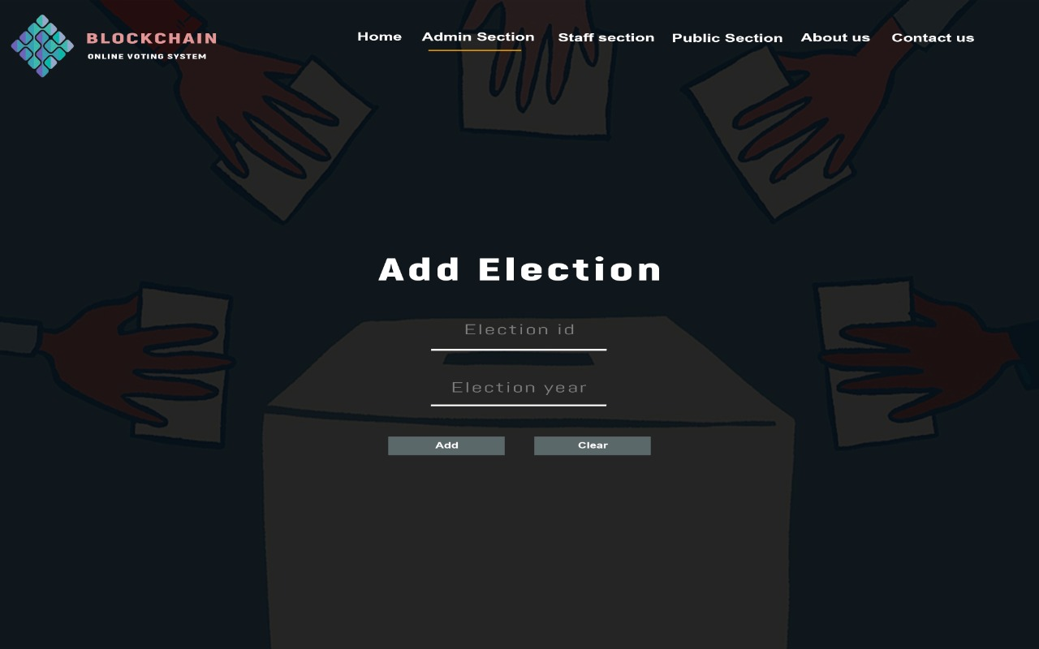



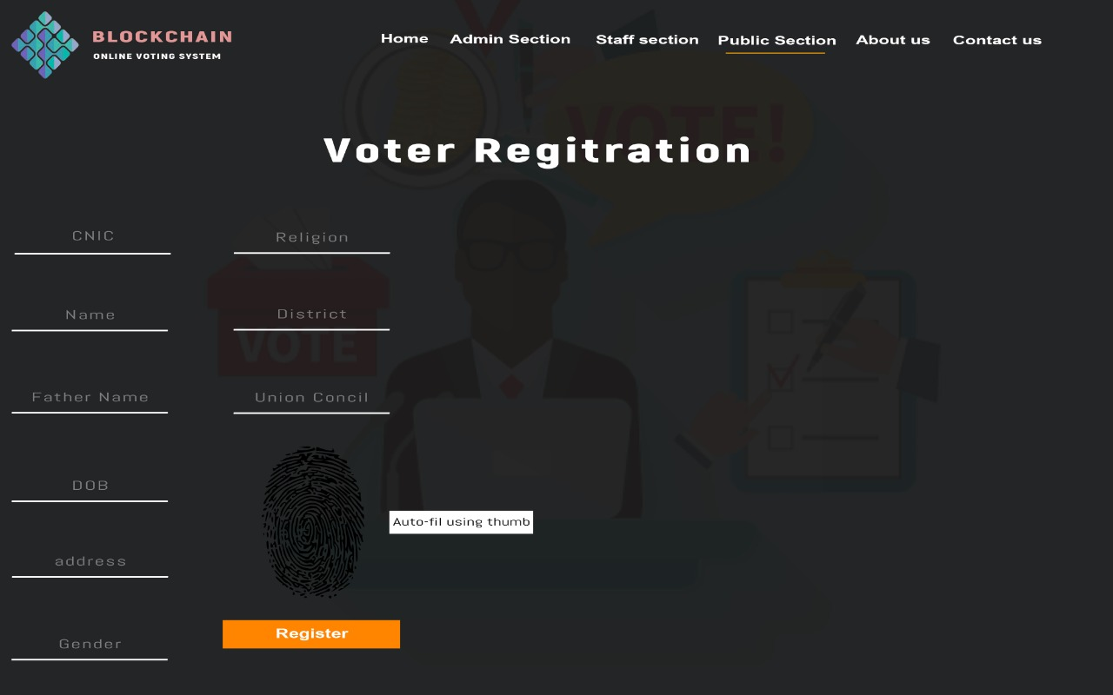

# 

# **17. Conclusion**

The Voting System is still maintained in paper format or database that can be tampered with. The main advantages of the Blockchain-based Electronic Voting System it enhanced security, transparency between voters and the government, and the voting system used API for the calculation of votes. And the government voting issue will be resolved by Dapp automatically. When the data is stored on the blockchain, then it becomes immutable and transparent. This system provides for resolving issues related to tempering in case of ambiguity and can help to detect false claims. Thus, our Dapp (Distributed App) can potentially replace not only physical data storage but also ensure high-end security with increased transparency.

# **18. References**

* Analysis of an Electronic Voting System in Various Countries

Mr. Sanjay Kumar1

Department of Computer Engineering, M. M. University,

Mullana (Ambala) 133207, India

* Analysis of an Electronic Voting System in Pakistan

Ghafoor, Ahmed

**Plagiarism Report**

Attach the Plagiarism report of your project scope document from the library staff of Turnitin tool (http://turnitin.com)